<<COURT_NAME>>

|  |  |
| --- | --- |
| <<PROVIDER_SUITNAME>>,  a/a/o <<INJUREDPARTY_NAME>>    Plaintiff,  vs.  <<INSURANCECOMPANY_SUITNAME>>  Defendant. | Case No. <<INDEXORAAA_NUMBER>> |

__________________________________________/

## MOTION FOR DEFAULT AND DEFAULT

Plaintiff, <<PROVIDER_SUITNAME>>, moves for entry of a default by the clerk against Defendant, <<INSURANCECOMPANY_SUITNAME>>, for failure to serve any paper on the undersigned or file any paper as required by law.

**CERTIFICATE OF SERVICE**

I HEREBY CERTIFY that on ­­­­­­­­­­­­­February 19, 2022, a true and correct copy of the foregoing was filed and served on the Defendant through the Florida E-File Portal.

**Florida Insurance Law Group, LLC**

6330 Manor Lane, Ste 200B

South Miami, FL 33143

Tel. (305) 906-4262

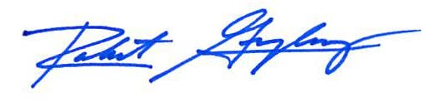

Robert F. Gonzalez, Esq.

Fla. Bar No. 68865

[Pleadings@flinslaw.com](mailto:Pleadings@flinslaw.com)

# DEFAULT

A default is entered in this action against the Defendant, <<INSURANCECOMPANY_SUITNAME>>, for failure to serve or file any paper as required by law.

Dated: ____________________

CLERK OF THE COURT

By _______________________

As Deputy Clerk